***System architecture***

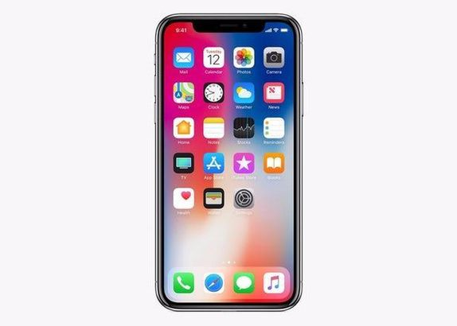

**User**

Mobile application

**Choose service**

**Arabic // English**

Database schema

